iTarang
IoT Stack Migration — Hostinger to AWS
A visual summary for the team

1. Why We Migrated
The plain-language version of the whole project.
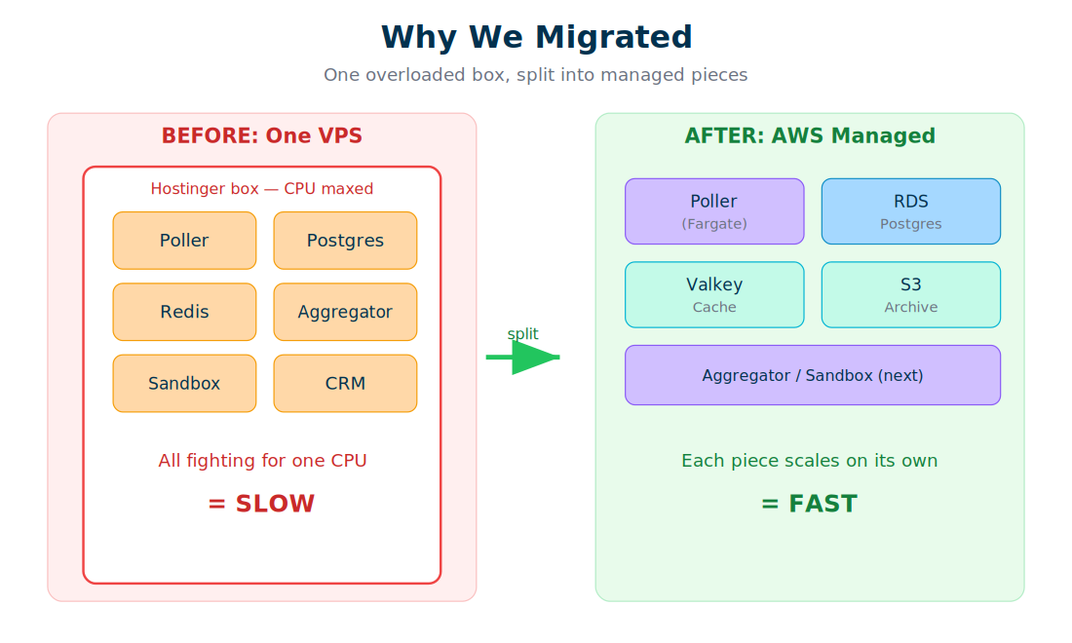
The old setup ran everything — the data poller, the database, the cache, the aggregator, the sandbox, and the CRM — on a single Hostinger box. They all competed for the same CPU, so as the fleet grew, the whole system slowed down. The fix wasn't a bigger box; it was splitting each job onto its own managed AWS service that scales independently. Now a busy poller can't starve the database, and each piece can grow on its own.

2. How Data Flows Now
The path a single telemetry reading takes, live, today.
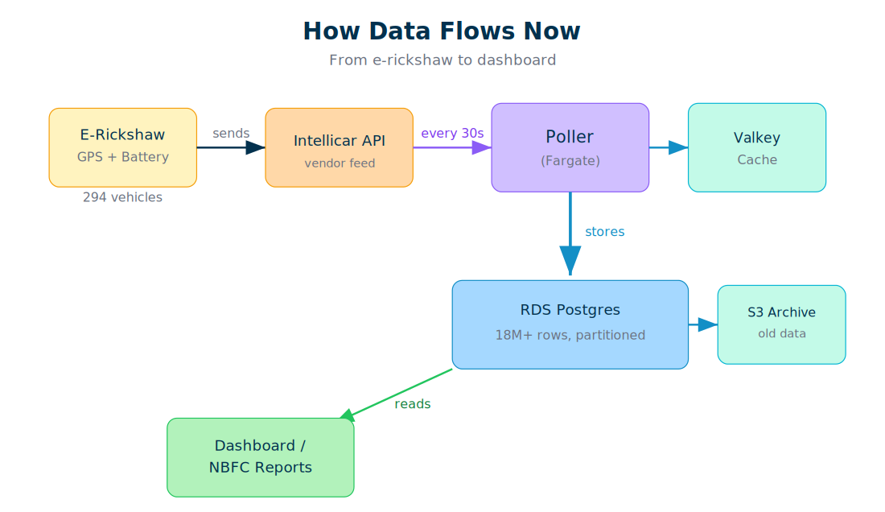
Each e-rickshaw reports GPS and battery data through the Intellicar API. The Poller, running on AWS Fargate, pulls fresh data every 30 seconds and writes it into RDS Postgres — now holding over 18 million rows, automatically organised into time-based partitions. Valkey caches frequently-used state so the poller stays fast, and older data is archived to low-cost S3 storage. Dashboards and NBFC reports read from RDS to show battery health, location, and alerts. This is the live pipeline — proven over 3,000+ cycles with zero errors.

3. The Migration Journey
The three phases we actually executed.
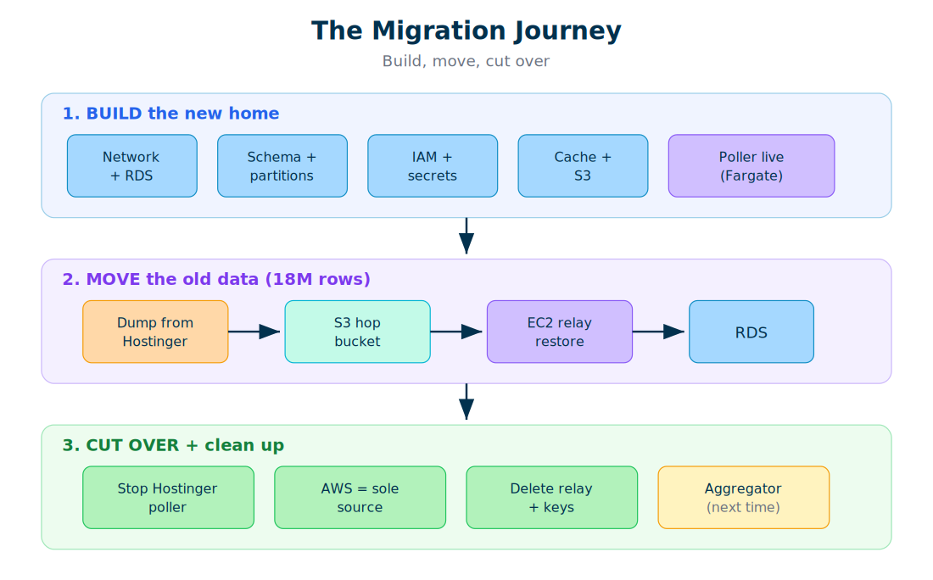
First we BUILT the new home on AWS — networking, the database with partitioning, security (IAM and encrypted secrets), the cache, archival storage, and the live poller. Then we MOVED 18 million rows of history: dumped from the old Timescale database, staged through an S3 'hop' bucket, and restored into RDS via a temporary EC2 relay that could reach both sides. Finally we CUT OVER — stopped the old poller so AWS became the single source of truth, and cleaned up all the throwaway migration tools. The one piece deliberately left for next time is the Aggregator, which computes the dashboard rollups.

Status at a glance
Done: Network, database + partitioning, security, cache, archive, live poller, daily battery backfill, and all historical data (telemetry, vehicles, users) — migrated and row-count verified.
Next: Deploy the Aggregator (powers dashboard rollups), then the sandbox and CRM, then retire the old Hostinger box.
Security to-do: Rotate the database, Intellicar, and dashboard credentials that were used during the build.

